Exp 4: OFDMA Resource Block Allocation Date

AIM: To simulate and analyze OFDMA (Orthogonal Frequency Division Multiple Access) resource block allocation and evaluate system performance in terms of resource utilization and user throughput using MATLAB.
Procedure
1. Define the system bandwidth and calculate the number of available resource blocks
(RBs) based on RB size (e.g., 180 kHz per RB).
2. Identify the number of active users in the OFDMA system for resource sharing.
3. Allocate resource blocks to each user based on a predefined or equal distribution strategy.
4. Compute Resource Block Utilization (%) using the ratio of allocated RBs to total RBs.
5. Assign modulation efficiency values (e.g., QPSK, 16-QAM, 64-QAM) for each user.
6. Calculate User Throughput (Mbps) using allocated RBs and modulation efficiency.
7. Plot graphs for RB allocation and utilization/throughput analysis using MATLAB.
8. Analyze results to evaluate spectrum efficiency and system performance.

Objective 1 : To determine the Number of Resource Blocks (RBs) allocated in an OFDMA system based on available bandwidth and system configuration.
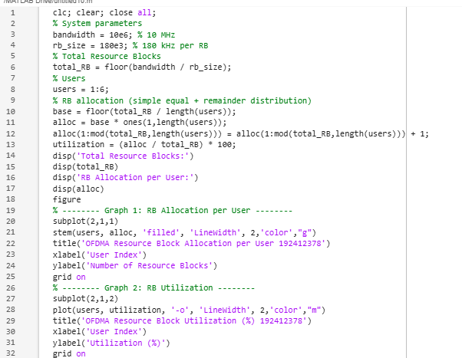

OUTPUT:
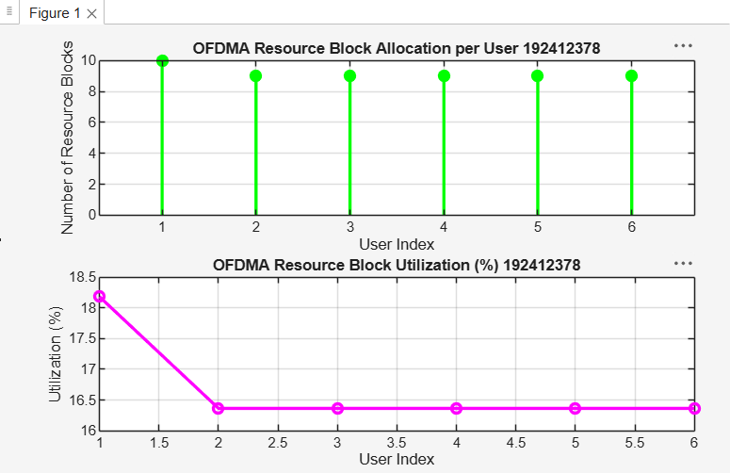

Result:
- The first graph shows how available resource blocks are distributed among multiple users in the OFDMA system.
- The second graph represents utilization efficiency, indicating how effectively the spectrum is shared among users.
Objective 2: To evaluate the Resource Block Utilization (%) by analyzing how efficiently available RBs are assigned to active users.
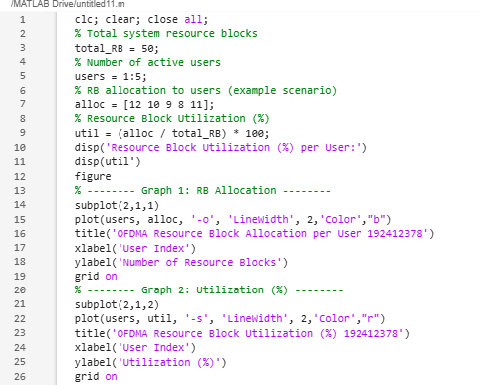

OUTPUT
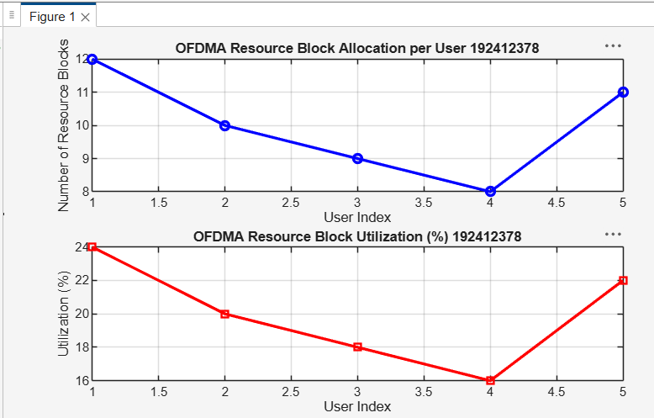

Result:
- The first graph shows how resource blocks are distributed among multiple users in the OFDMA system.
- The second graph indicates the efficiency of spectrum usage by each user in terms of percentage utilization.
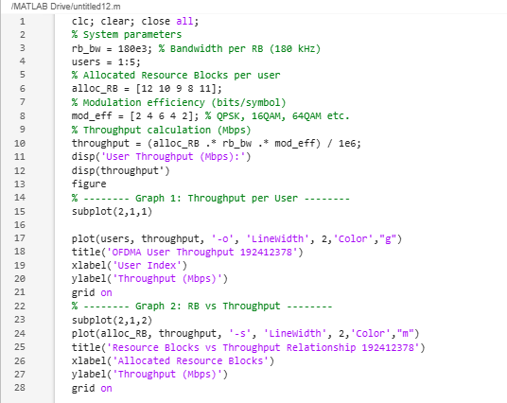
Objective 3: To calculate the User Throughput (Mbps) based on allocated resource blocks and modulation efficiency in the OFDMA system.

OUTPUT:
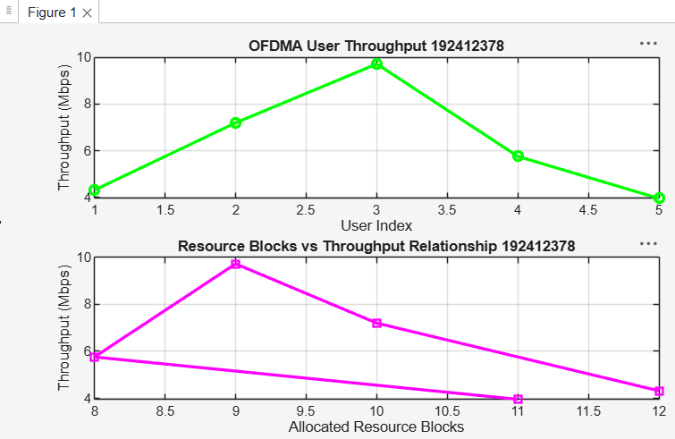

Result:
- The first graph shows that user throughput increases with higher modulation efficiency and allocated resource blocks.
- The second graph clearly indicates a linear relationship between resource blocks and achieved throughput in OFDMA systems.

